Name: Meratun Junnut Anee

Id:1620527043

Title**: Development and Validation of a UAV Based System for Air Pollution Measurements**

Publisher: **MDPI**

Author:

Tommaso Francesco Villa (1), Farhad Salimi (2), Kye Morton (3), Lidia Morawska (1)* and Felipe Gonzalez (3)

Date of publication: **21 December, 2016**

Review:

The purpose of this project is to establish the best mounting point for 4types of gas sensor and a particle number concentration (PNC) monitor, onboard hexacopter. They tasted two different things:

* Evaluate the air flow behavior of hexacopter, it’s directional effect, airspeed, 3-axis to helicopter to determine the location.
* Evaluate the gas sensors for Co2 , CO, NO, No2 and PNC monitor.

They examined that they got the best results with the airspeed behavior map produced by test1, the best mounting point. Test 2 resulted that the propellers cause a dispersion effect shown by decreasing of gas and PN concentration.

They also used a linear regression model to estimate the sensor position relative to the UAV center, where the pollutants concentration is higher and where the propellers switch on.

The UAV pilot, UAV GSO( ground station operator ) could connect with UAV wirelessly, using a radio controller transmitter or a computer.

|  |  |
| --- | --- |
| UAV Components | UAV Ground Components |
| Gas sensors | RC transmitter |
| Arduino | Ground Station |
| Battery | Telemetry link |
| DISC mini |  |
| RC receiver |  |
| S800Frame |  |

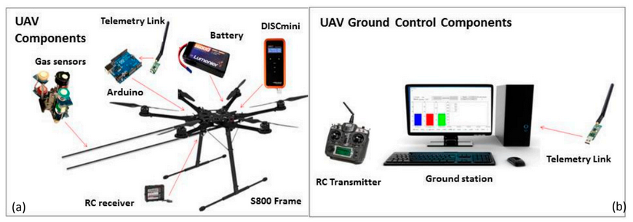

They used a radio modem to transmit real data including information . They did their research from Australian research centre of aerospace automation indoor flying lab.

In test – 2, they went the 3 types of questions:

* How does the status of propellers (on/off) affect the measured gas and particle concentration?
* How does the position of the sensor(below/above/inside) affect the concentration?
* How does the distance from the UAV center affects the measured gas and particle concentration?

Advantage:

* Usable nationally and internally.
* Reliable project

Disadvantage:

* Long process
* Complex project
* Costly